INTERNSHIP REPORT

UI/UX Design with Figma & Adobe XD

A Summer Internship Report submitted in partial fulfillment of the requirements for the award of degree of

MASTER OF COMPUTER APPLICATIONS

Submitted
By
Saka Sri Praveen 24M11MC152


DEPARTMENT OF COMPUTER APPLICATIONS

ADITYA UNIVERSITY

A.Y. 2025-26

DEPARTMENT OF COMPUTER APPLICATIONS

CERTIFICATE
This is to certify that the internship report entitled “UI/UX Design with Figma & Adobe XD” is being submitted by Saka Sri Praveen - 24M11MC152 in partial fulfillment of the requirements for the award of the degree of Master of Computer Applications in the Department of Computer Applications for the academic year 2024–2025.
This report is based on the internship carried out at BLACKBUCK ENGINEERS, and it reflects the students’ own work, conducted under our guidance and supervision.

Guide/Supervisor Name Head of the Department

Mr. K. NAGA BABU | Dr. M. VAMSIKRISHNA
Assistant Professor | Professor

DECLARATION
I hereby declare that the internship report entitled “UI/UX Design with Figma & Adobe XD” is a genuine and original work submitted to Aditya University, Surampalem, in partial fulfillment of the requirements for the award of the Master of Computer Applications (MCA) degree.
I further declare that this report has not been submitted, either in full or in part, for the award of any degree or diploma at this or any other educational institution.

by
Saka Sri Praveen 24M11MC152

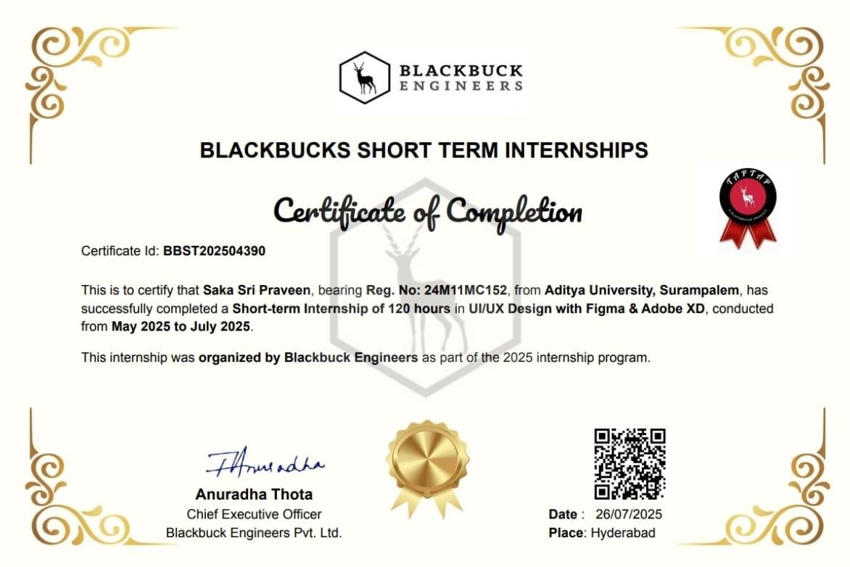
Internship Certificate

ACKNOWLEDGEMENT

First and foremost, I would like to express my sincere gratitude to Ms. Anuradha Thota, Director of Blackbuck Engineers, for providing me with the opportunity to undertake my internship within the organization. I am also thankful to all the team members at Blackbuck Engineers, Hyderabad, for their patience, cooperation, and the friendly work environment they created, which made the experience truly enjoyable.
It is with immense pleasure that I express my sincere thanks to Mr. Ritik Patidar, Assistant Professor and Internship Coordinator, for coordinating the internship process and facilitating the smooth submission and evaluation of reports.
I am deeply grateful to Dr. M. Vamsikrishna, Head of the Department, for his motivation, support, and for arranging all the necessary facilities and resources for the smooth execution of my internship project.
I also wish to extend my heartfelt thanks to Mrs. B. Prameela Rani, Assistant Professor and my project guide, for her encouragement, valuable feedback, and consistent support throughout my internship.
I am thankful to the respected leadership of Aditya University for their unconditional support and for providing world-class infrastructure and state-of-the-art laboratories. My sincere thanks to:
- Dr. Satish Reddy N, Pro Chancellor
- Dr. M. Sreenivasa Reddy, Deputy Pro Chancellor
- Dr. MB. Srinivas, Vice Chancellor
- Dr. S. Rama Sree, Pro-Vice Chancellor (Academics)
- Dr. Ramesh A, Pro-Vice Chancellor (Engineering & Sciences)
- Dr. Suresh G, Registrar
- Dr. M. Venkata Rajesh, Associate Dean of Academics
Lastly, I would like to thank all the faculty members, lab technicians, non-teaching staff, and my friends who directly or indirectly helped and supported me in successfully completing my internship project on time.

SUMMER INTERNSHIP ABSTRACT

The Summer Internship Program at Blackbuck Engineers Pvt. Ltd. provided an immersive and hands-on learning experience in UI/UX Design, focusing on industry-standard tools such as Figma and Adobe XD. Over the course of six weeks, I engaged in a structured curriculum that combined theoretical foundations with practical applications, enabling me to understand and apply core design principles in real-world scenarios.
The internship began with onboarding and orientation sessions that introduced the fundamentals of user interface and user experience design. I explored key concepts such as design thinking, user-centered design, wireframing, and prototyping, and gradually progressed to advanced topics including responsive layouts, interactive components, and usability testing.
Throughout the program, I participated in live sessions, assessments, and assignments that challenged me to design intuitive and visually appealing interfaces. I learned to create low- fidelity wireframes, high-fidelity mockups, and interactive prototypes that simulate real user interactions. These exercises helped me develop a strong grasp of visual hierarchy, typography, color theory, and accessibility standards.
Collaboration played a vital role in my learning journey. I received feedback from mentors and peers, which helped me refine my designs and improve my problem-solving approach. I also gained exposure to version control using Git, design documentation, and project handover practices, which are essential for working in professional design teams.
By the end of the internship, I had successfully completed multiple design tasks and contributed to a capstone project that demonstrated my ability to apply UI/UX principles effectively. This experience not only enhanced my technical proficiency but also strengthened my communication, time management, and creative thinking skills.
Overall, the internship has prepared me to take on future roles in UI/UX design, product development, and front-end engineering, and has given me the confidence to contribute meaningfully to user-focused digital solutions.

About organization
Blackbuck Engineers is a Hyderabad-based technology company that focuses on software solutions, product development, and training programs. The organization is well known for its innovative approach to bridging the gap between academia and industry by offering structured internship programs in emerging domains such as UI/UX Design, Web Development, Game Development, and Full-Stack Development.
As part of its flagship initiative TAPTAP, Blackbuck Engineers provides short-term internships designed to give students practical exposure to industry-standard tools and workflows. These programs emphasize hands-on learning, mentorship, and project-based training, ensuring that participants gain real-world experience alongside theoretical knowledge.
The company’s mission is to empower aspiring developers and designers by equipping them with the skills required to thrive in the competitive tech industry. Interns are guided by experienced professionals who provide valuable feedback, encourage creativity, and foster collaborative learning environments.
Blackbuck Engineers has built a strong reputation for:
- Delivering industry-relevant training in modern technologies.
- Encouraging innovation and design thinking among students.
- Providing career-oriented opportunities through placement tests and performance- based evaluations.
- Maintaining a culture of professionalism, mentorship, and continuous improvement.
By combining structured learning with practical application, Blackbuck Engineers ensures that students like me are job-ready from day one. My internship in UI/UX Design with Figma & Adobe XD under this organization allowed me to gain valuable insights into design principles, usability testing, and collaborative workflows, preparing me for future roles in the field of software and product design

INDEX

S.No | Contents | Page No
1 | CERTIFICATE | 2
2 | DECLARATION | 3
3 | ACKNOWLEDGEMENT | 5
4 | SUMMER INTERNSHIP ABSTRACT | 6-7
5 | Week 1 Report | 9
6 | Week 2 Report | 10
7 | Week 3 Report | 11
8 | Week 4 Report | 12
9 | Week 5 Report | 13
10 | Week 6 Report | 14
11 | Overall Outcomes | 15-17

Week 1 Report: Orientation & Onboarding

 | DATE | DAY | NAMEOFTHETOPIC/MODULECOMPLETED
 | 19-05-2025 | Monday | Prerequisites Videos
 | 20-05-2025 | Tuesday | Webinar
 | 21-05-2025 | Wednesday | Onboarding Session
 | 22-05-2025 | Thursday | Domain Test
 | 23-05-2025 | Friday | MET for Batch 02
 | 24-05-2025 | Saturday | Prerequisites Videos

Overview

- Learned the prerequisites for UI/UX design, including basics of design thinking and tool setup.
- Attended a webinar introducing the internship structure and expectations.
- Participated in the onboarding session, where domains like Android, MERN, Java, Game Development, and UI/UX were explained.
- Completed the Domain Test, which assessed initial knowledge and readiness for UI/UX design.
- Took part in the MET, which helped identify strengths and areas for improvement.

Conclusion:
Week 1 provided a strong foundation by familiarizing me with the internship process, tools, and expectations. Through onboarding and initial assessments, I gained clarity on the UI/UX domain and understood the skills required for the upcoming weeks. This week helped me transition smoothly into the program and prepared me for hands-on design sessions.

Week 2 Report: Foundations of UI/UX

 | DATE | DAY | NAMEOFTHETOPIC/MODULECOMPLETED
 | 26-05-2025 | Monday | MET Test
 | 27-05-2025 | Tuesday | Placement Test -1
 | 28-05-2025 | Wednesday | Session 01 - UI/UX
 | 29-05-2025 | Thursday | Assessment 1
 | 30-05-2025 | Friday | Assignment 01
 | 31-05-2025 | Saturday | Session 02 - UI/UX
Overview
  - Attempted the MET Test to evaluate initial understanding.
  - Completed Placement Test – 1 to assess domain knowledge.
  - Attended Session 01 on UI/UX fundamentals, focusing on design principles and Figma basics.
  - Completed Assessment 1 to reinforce learning outcomes.
  - Worked on Assignment 01 to apply concepts practically.
  - Attended Session 02 on UI/UX, covering interactive design elements.

Conclusion
Week 2 strengthened my foundation in UI/UX design. I learned the basics of Figma and Adobe XD, practiced wireframing, and understood user-centered design principles. This week helped me transition from theory to practical application.

Week 3 Report: Intermediate Design
 | DATE | DAY | NAMEOFTHETOPIC/MODULECOMPLETED
 | 16-06-2025 | Monday | Placement Test -3
 | 17-06-2025 | Tuesday | Session 07 - UI/UX
 | 18-06-2025 | Wednesday | Assessment 7
 | 19-06-2025 | Thursday | Session 08 - UI/UX
 | 20-06-2025 | Friday | Assessment 8
 | 21-06-2025 | Saturday | Assignment 3

Overview
- Attempted Placement Test – 3 to measure progress.
- Attended Session 07 on UI/UX, focusing on design systems and consistency.
- Completed Assessment 7 to evaluate understanding of design workflows.
- Attended Session 08 on UI/UX, covering user flows and interactive components.
- Completed Assessment 8 to reinforce advanced concepts.
- Submitted Assignment 3, applying intermediate design techniques.

Conclusion
Week 3 focused on intermediate concepts like design systems, user flows, and interactive components. I improved consistency in my designs and gained confidence in usability awareness, preparing me for advanced prototyping.

Week 4 Report: Advanced Prototyping
 | DATE | DAY | NAMEOFTHETOPIC/MODULECOMPLETED
 | 23-06-2025 | Monday | Session 09 - UI/UX
 | 24-06-2025 | Tuesday | Assessment 09
 | 25-06-2025 | Wednesday | Session 10 - UI/UX
 | 26-06-2025 | Thursday | Assessment 10
 | 27-06-2025 | Friday | Placement Test -4
 | 28-06-2025 | Saturday | Assignment 05

Overview
- Attended Session 09 on advanced UI/UX design.
- Completed Assessment 09 to test knowledge of high-fidelity design.
- Attended Session 10 on prototyping and usability testing.
- Completed Assessment 10 to validate design workflows.
- Attempted Placement Test – 4 to measure overall progress.
- Submitted Assignment 05, focusing on advanced prototypes.

Conclusion

Week 4 helped me create high-fidelity prototypes and conduct usability testing. I learned how to validate design ideas, optimize user flows, and present them effectively to mentors and peers.

Week 5 Report: Design Evaluation

 | DATE | DAY | NAMEOFTHETOPIC/MODULECOMPLETED
 | 30-06-2025 | Monday | Session 11 UI/UX Design
 | 01-07-2025 | Tuesday | Assessment 11 Grand Test 01
 | 02-07-2025 | Wednesday | Placement Test -5
 | 03-07-2025 | Thursday | Session 12 UI/UX Design
 | 04-07-2025 | Friday | Assignment 12
 | 05-07-2025 | Saturday | Assignment 05

Overview
- Attended Session 11 on UI/UX design evaluation.
- Completed Assessment 11 (Grand Test 01) to test cumulative knowledge.
- Attempted Placement Test – 5 to assess readiness for final projects.
- Attended Session 12 on UI/UX, focusing on refinement and feedback.
- Submitted Assignment 12, applying design improvements.
- Worked on additional assignments to strengthen practical skills.

Conclusion
Week 5 emphasized evaluation and refinement. I strengthened my design thinking, incorporated feedback, and improved layouts for better usability. This week prepared me for final project deliverables.

Week 6 Report: Recap & Finalization

 | DATE | DAY | NAMEOFTHETOPIC/MODULECOMPLETED
 | 07-07-2025 | Monday | MET July
 | 08-07-2025 | Tuesday | Session 13 (Recap 01)
 | 09-07-2025 | Wednesday | Assessment 13
 | 10-07-2025 | Thursday | Session 14 (Recap 02)
 | 11-07-2025 | Friday | Assessment 14
 | 12-07-2025 | Saturday | Session 15 (Recap 03)

Overview
- Attempted MET July evaluation to conclude internship progress.
- Attended Session 13 (Recap 01) to review core concepts.
- Completed Assessment 13 to reinforce learning.
- Attended Session 14 (Recap 02) for advanced review.
- Completed Assessment 14 to validate understanding.
- Attended Session 15 (Recap 03) to finalize project outcomes.

Conclusion
Week 6 consolidated all concepts learned during the internship. I finalized my project deliverables, reviewed key principles, and completed the program with a strong grasp of the UI/UX design lifecycle. This week marked the successful completion of my internship journey.

Overall Outcomes
The six-week internship at Blackbuck Engineers in UI/UX Design with Figma & Adobe XD was a transformative experience that bridged the gap between academic knowledge and industry practice. It provided me with hands-on exposure to modern design tools, workflows, and professional standards, while also strengthening my problem-solving and collaboration skills.
Throughout the internship, I gained proficiency in wireframing, prototyping, and responsive design, learning how to translate user requirements into intuitive digital interfaces. I mastered the use of Figma and Adobe XD to create interactive prototypes, design systems, and high-fidelity mockups. These tools allowed me to experiment with layouts, typography, and color theory, while ensuring accessibility and usability for diverse audiences.
The program emphasized user-centered design principles, teaching me to approach every project with empathy and focus on real user needs. By conducting usability testing and incorporating mentor feedback, I learned the importance of iteration and refinement in the design lifecycle. This process improved my ability to balance creativity with functionality, ensuring that designs were both visually appealing and practical.
Beyond technical skills, the internship enhanced my professional competencies. I developed strong communication skills by presenting my work to mentors and peers, learned to manage deadlines through structured assignments and assessments, and practiced documentation for project handover. Collaboration with fellow interns and guidance from industry experts helped me understand the value of teamwork and constructive feedback in achieving high-quality outcomes.
The challenges I faced—such as adapting to new tools, managing time effectively, and maintaining design consistency—taught me resilience and adaptability. By overcoming these obstacles, I became more confident in my ability to handle real-world projects and deliver solutions under pressure.
Overall, this internship has prepared me for future roles in UI/UX design, product development, and front-end engineering. It has given me the confidence to contribute meaningfully to digital solutions, equipped me with industry-relevant skills, and inspired me to continue learning and innovating in the field of design. The experience has been a crucial step in my journey toward becoming a professional software developer and designer, and it will serve as a strong foundation for my career ahead.

Skills Learned
During my internship, I gained both technical and professional skills essential for UI/UX design and software development:
- UI/UX Fundamentals – design thinking, user-centered design, usability, accessibility.
- Wireframing & Prototyping – low- and high-fidelity designs for mobile/web.
- Responsive Design – adaptable layouts for diverse screen sizes.
- Visual Principles – typography, color theory, contrast, hierarchy.
- Usability Testing – identifying flaws and refining designs.
- Collaboration & Communication – constructive feedback in team settings.
- Time Management & Discipline – balancing deadlines and tasks.
- Documentation Skills – structured design documentation for clarity.

Tools & Technologies
- Figma – collaborative wireframing and prototyping.
- Adobe XD – high-fidelity mockups and interactive prototypes.
- Git & Version Control – managing design files.
- Documentation Tools – structured project handover.
- Collaboration Platforms – online discussions and submissions.
- Testing Tools – usability validation.

Challenges & Solutions
- Tool Familiarity – overcame through regular practice.
- Balancing Creativity & Usability – applied design standards.
- Time Constraints – daily task scheduling.
- Feedback Implementation – iterative design improvements.
- Consistency – built reusable design systems.
- Presentation Skills – improved through peer collaboration.

Internship Learnings
- User-centered approach with empathy.
- Full lifecycle: brainstorming → prototyping → testing.
- Teamwork and peer reviews enhanced outcomes.
- Professional discipline in deadlines and documentation.
- Industry readiness through real-world workflows.
- Critical thinking and adaptability to evolving requirements.

Future Scope
  - Roles: UI/UX Designer, Product Designer, Front-End Developer.
  - Advanced tools: Sketch, InVision, enterprise design systems.
  - Specialization: usability testing, accessibility, design psychology.
  - Continuous learning in trends and frameworks.
  - Contribution to academic, freelance, and industry projects.
  - Research in AI-driven design tools.
  - Entrepreneurship in digital product development.

References
  - Books: Don’t Make Me Think (Steve Krug), The Design of Everyday Things (Don Norman).
  - Websites: Figma Docs, Adobe XD Tutorials, Nielsen Norman Group, Google Material Design.
  - Platforms: Figma Community, Adobe XD Resource Kits, GitHub.

